Application: Step by Step
Deutsche Version: Bewerbung: Schritt für Schritt

In this article you will learn
- the general steps of the application procedure
- what to pay attention while applying
Also helpful
- Activating application account
- How to download application related documents (e.g. letter of admission, letter of rejection)
- FAQ: Application through HISinOne
- How to re-upload a document in your application after submission
- Application account at University of Freiburg and hochschulstart.de
- How to make a matriculation request in HISinOne after getting admitted to a course of study

1. a) use an existing Uni-Account
If you already are a student at the University of Freiburg and have a UniAccount, you can log in with your existing account and start the application using „Studies offered“ and „Online Application“.
If you have a UniAccount as an employee of the University of Freiburg, you can't use your existing account for an online application. Instead, you have to create a new account.
\\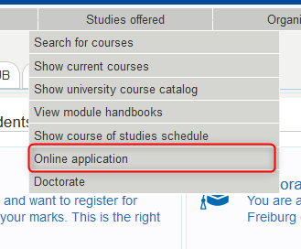

1. b) self-registration
- Start the self-registration process on https://campus.uni-freiburg.de (Menu „Appliction“)
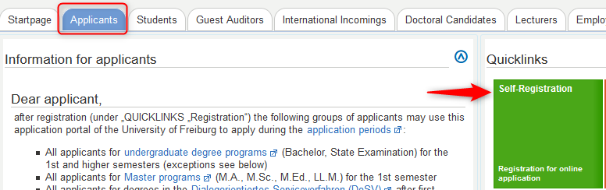
- Read carefully the information on when you should and shouldn’t register for an application-account. Click „OK”, if you are eligible for registration.
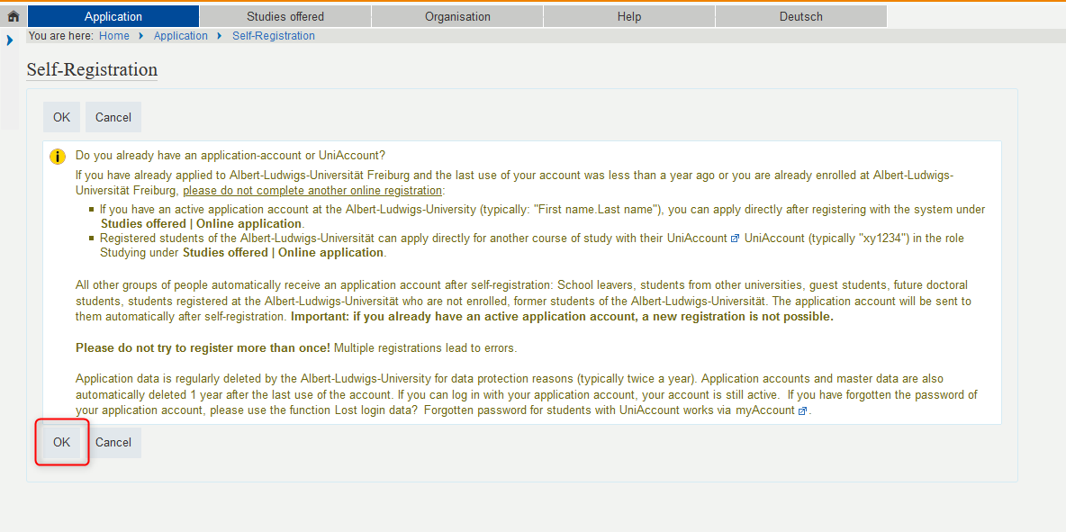
- Please note the information on applying for courses of study with registration on hochschulstart.de and the information on self-registration in HISinone. Enter your personal data and finish with clicking on „Register“. The fields marked with * are mandatory. For some fields you can get additional information by pressing the info-button .
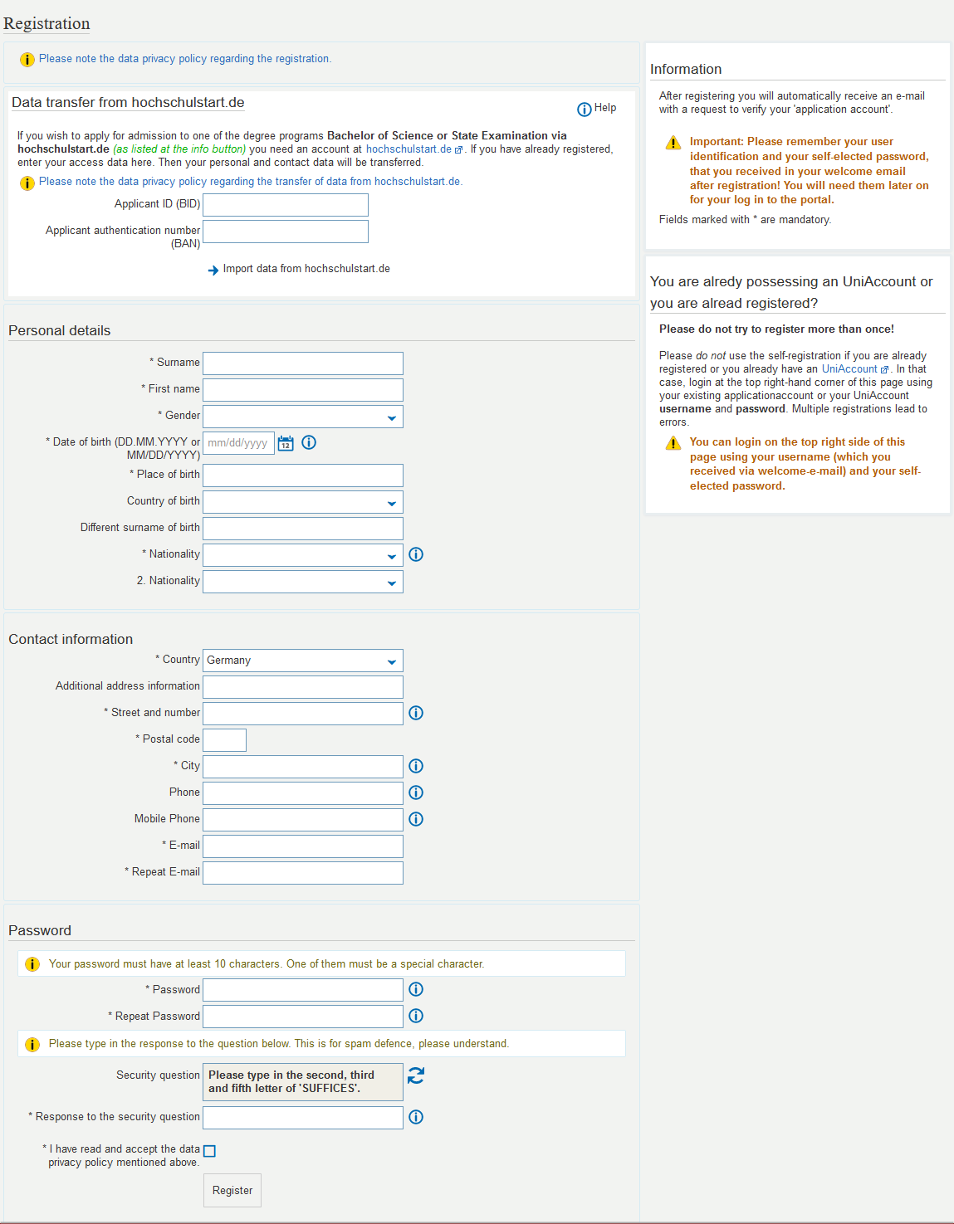
- After successfull self-registration you receive a mail to activate your application account. You can click the link in the mail, or you can enter the activation code manually.
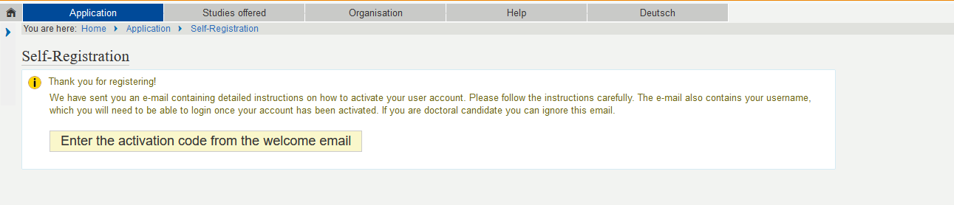
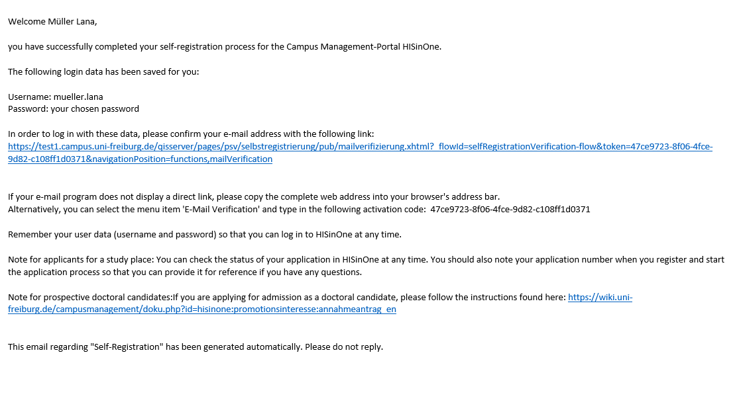 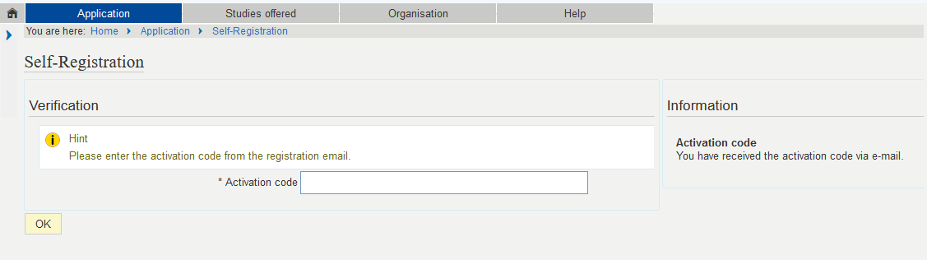
 | Unfortunately, activation with the code/link doesn't work for the employees of the University of Freiburg. Please contact the hotline: study@uni-freiburg.de to activate your account.
- Now you have successfully created your application-account! You can sign in with your Username (last name.first name) and the password you created in the registration process.
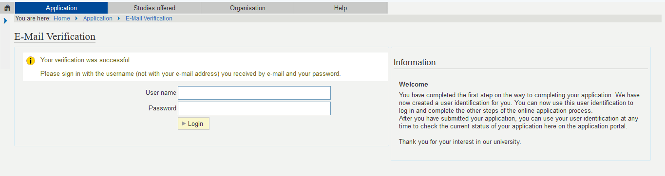

2. start the online application
- After successful activation of your self-registered accout you can now start your online application. Click on “Start Application”.
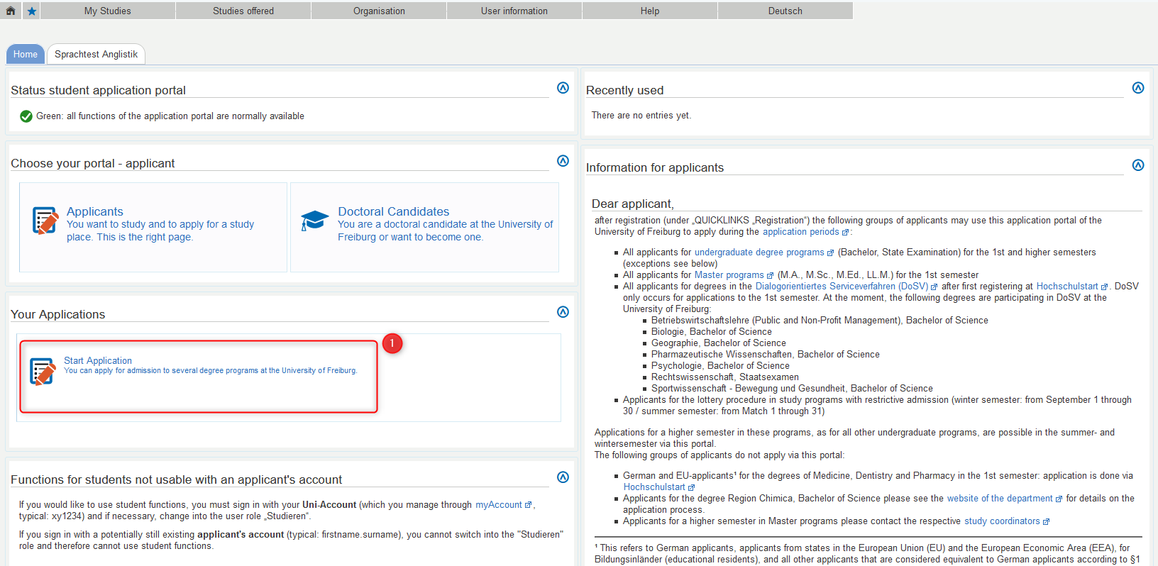
- Click on “Add an application”.
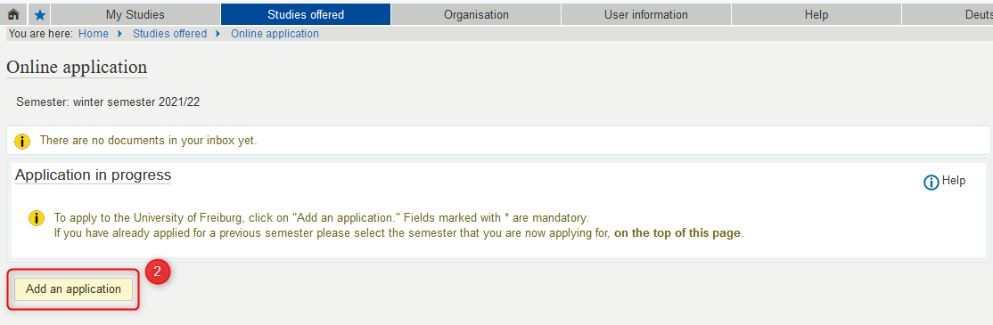

3. course of choice
Please be aware that you have a limited choice of subjects and degrees depending on semester you apply for. That depends on different application periods (start dates and deadlines).
- Please choose your desired degree first.
- Please chose your subject afterwards.
- Please choose Major or Minor.
- Please choose your form of studies.
- Please choose your course of studies.
- Finally select the semester in which you want to commence your studies.
- …and click „Next“
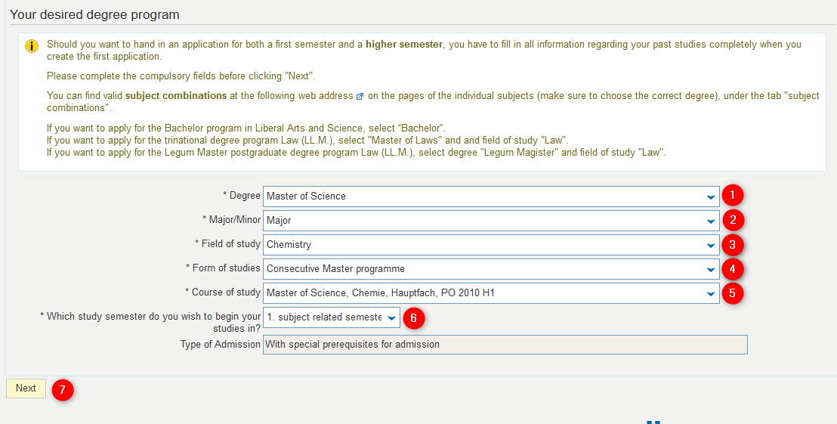

4. previous studies in Germany
- This information is only relevant for those who are applying for a bachelor program.
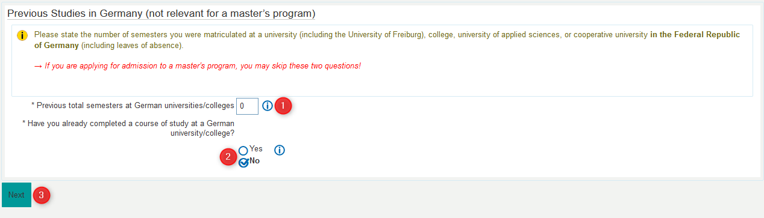

5. University Entrance Qualification
- Please select wether you optained your university entrance entitlement in Germany or abroad.
- If you chose „abroad“ above, please select the country where you obtained your entrance entitlement. Otherwise select the county.
- Please select the type of entrance entitlement.
- Please enter the grade
- Please enter your graduation date (as on certificate)
- …and click „Next“
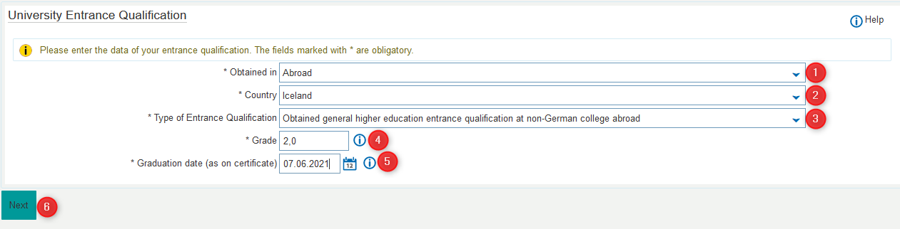
 | If you don't have your grade yet, you can leave the field empty. In this case, you have to leave the field „graduation date“ empty as well!

6. documents upload
- Please upload your complete university entrance qualification according to the specific requirements. Click „Next“.
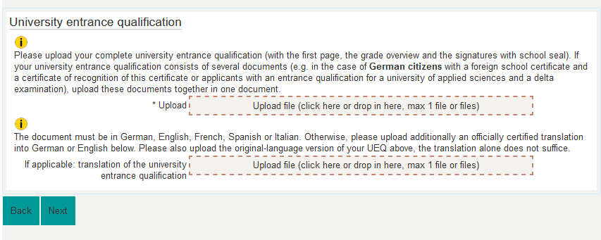
- Please upload the proof participation in a study orientation test if available. You do not have to upload it now, but it must be submitted no later than enrollment. After that, click „Next“
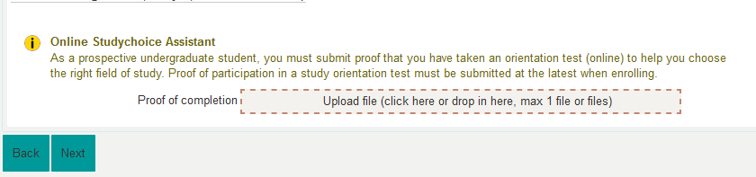

7. German proficiency
- Please enter your level of German proficiency and the name of your officially authenticated language certificate. See information sheet https://www.studium.uni-freiburg.de/de/bewerbung/bls/docs/merkblatt-zu-beglaubigungen
- If you language certificate is not listed above please enter the name of your language certificate here. Here you can find a list of the accepted C1 language certificates: https://www.studium.uni-freiburg.de/en/application/international-student-admissions/full-time-studies
- Please upload your language certificate here. The language certificate must be in German, English or French. Otherwise please upload an officially certified translation into German or English.
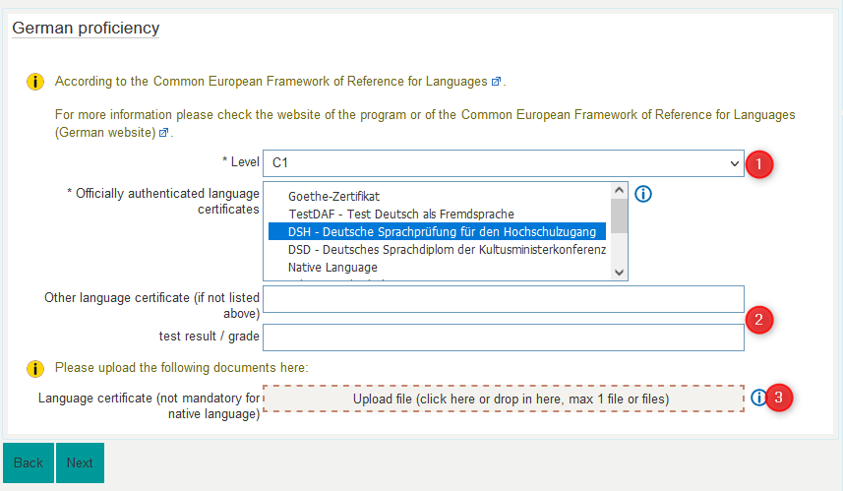

8. other documents
- Depending on the program you are applying for: Please upload the required documents.
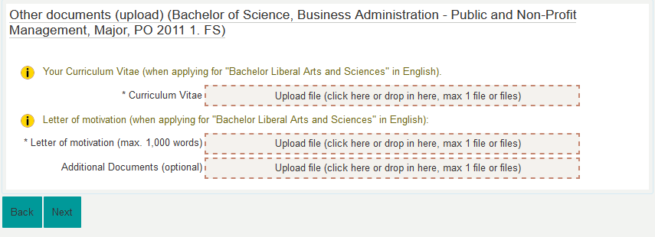

9. confirmation of your data
- Please download and fill out the PDF document. E-signature is also accepted.
- Please upload the document at the designated space.
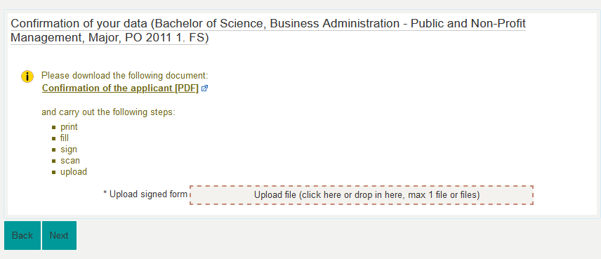
- You have now entered all necessary information for your application. Please review your application for admission before submitting it to make sure you didn't make any mistakes. After that you have to scroll down to the bottom of the page, check the box and click on „submit“.
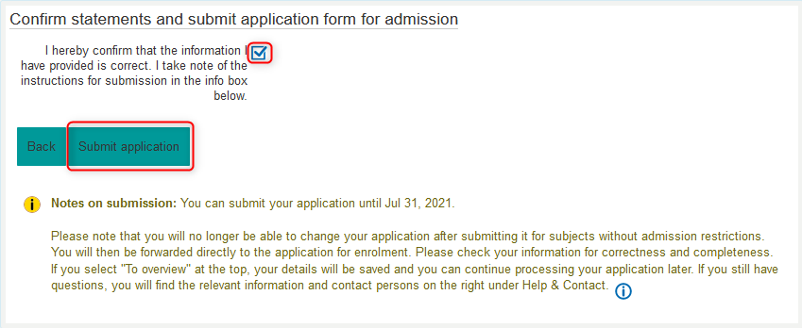
- After you successfully submitted your application, you will receive the following confirmation e-mail.
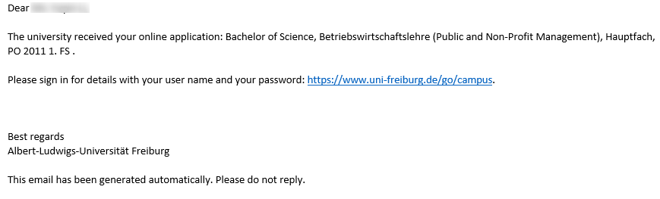

10. adding another application
- Please click on “View my application”.
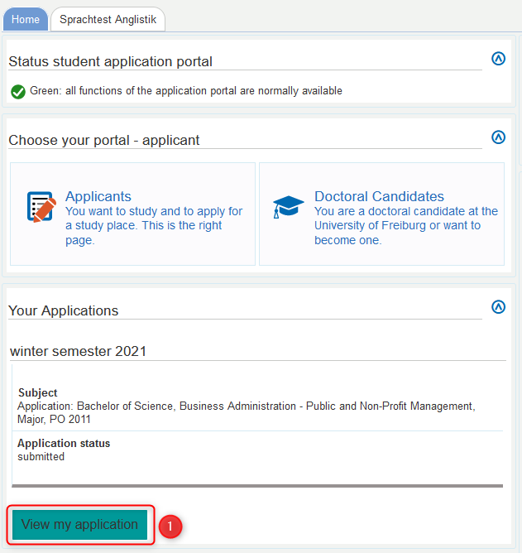
- Please click on “Add an application”.
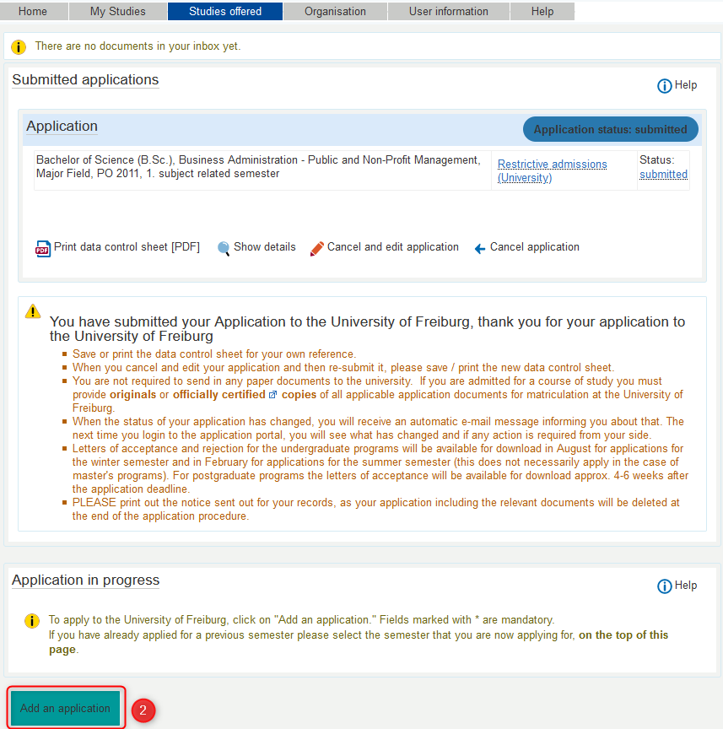

11. Application related documents and immatriculation
- In HISinOne you can view and download documents regarding your application. When you have received the letter of acceptance, you can also submit request for immatriculation here.
We wish you success with the application!

