Address registration and address change for (prospective) doctoral candidates
German Version: Adresserfassung und Adressänderung für Promovierende und Promotionsinteressierte

Information: For data protection reasons, private contact info of employees is not imported automatically to HISinOne from the personnel management systems. Therefore, employees that wish to apply for a doctoral candidate position must complete their information in HISinOne.
To edit your contact info, please follow these steps:
- 'Service' → 'Personal settings'
- Choose the tab 'Edit my contact data'
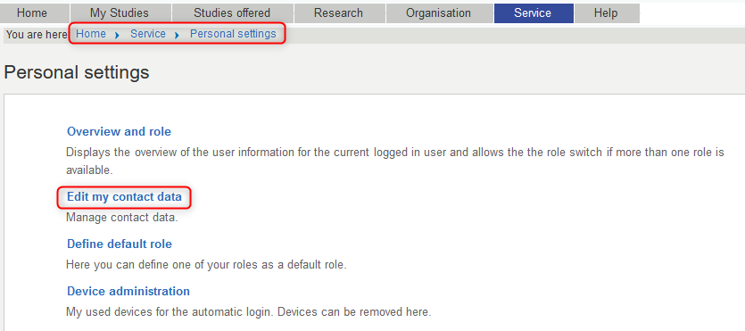
- Edit '(3-K) Doctorate - Correspondance' by clicking the pencil icon If no. '(3-K) Doctorate - Correspondance' tile is displayed: Add application purpose'
- Edit an existing adress (1) or 'Add Postadress' (2)
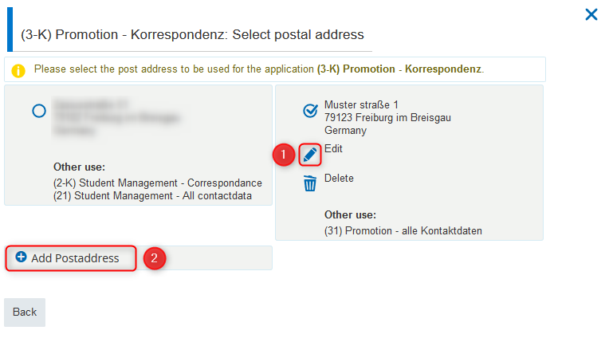
- Edit your contact data (1) and 'Save' (2).
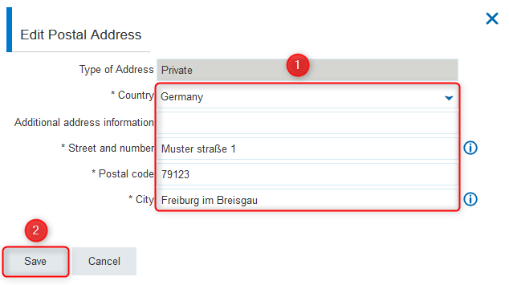
Studentscan also read this manual for the change of address in HISinOne according to instructions

